Proposal
For
Multilingual Legal Services Web & App Development



Company Profile:

Karmick Solutions Pvt. Ltd. is an ISO 9001:2015 certified IT consulting company based in Kolkata, India with experience of 21+ years. We provide solutions in Web Design and Development, Mobile Apps Development and Digital Marketing across various industry verticals like Manufacturing, Mining, Travel & hospitality, Education, e-Governance etc. with clientele including enterprise clients, emerging start-ups, Government agencies and digital agencies, spread across 36 countries worldwide.

We had started with the motto of building relationships, and not just building applications. Our goal is to understand client’s business, their vision and mission and align ourselves to those. This has helped us win our client’s trust and also not only to remain profitable from year one of our business but also have helped us with steady business and customer acquisitions even during economic recessions that had hit the IT industry worldwide.

With an in-house team of around 150+ PHP Developers, Mobile Application Developers, Designers, SEO/SMO Professionals and Content Writers spread over 2 development units in Kolkata and with office in Largo, Maryland, US, we make use of the latest web design and development technology that meets your digital requirements.

Led by a strong management team, we ensure the quality of development by having in place a standard set of QA process for every project that we undertake. The work process involves QA at every stage of development before it passes to the client thereby ensuring quality works reaching the client which accordingly ensures 100% client satisfaction.

Our Advantages:

- End to End Solution provider for IT projects – Branding, Website Development, Mobile Application Development, and Digital Marketing. We work in DESIGN, BUILD, DEPLOY, SCALE, MAINTAIN mode thereby providing a one stop solution centre to our clients.

- Tech Skills – We always try to innovate and always intend to remain updated with the latest technology trends. We have skillset in not only Cloud technology but also IoT, Artificial Intelligence which gives us an edge over our competitors.

- We have a strong Information Security Management System in place. Protected Data Centre, authorized entry to the workstations, Firewalls to protect from any threats. Security audits are done to ensure our customer data is secure and protected from any unauthorized access.

- Client centric approach – aligning ourselves to client’s business goals. Our ultimate goal is to provide perfect value to the customer through a perfect value creation process that has near to zero waste.

- We reach out to our clients. We visit our clients in US, Europe, Middle East, and Africa in person. We believe in building relationships.

- The team speaks English – So communication is seamless with any client throughout the world. Communication is the key – so the team is available via Skype/Email/WhatsApp almost 24/7.

- Team works using AGILE. Daily SCRUMs and Weekly Sprints keep the deviation minimal. We use Project Management tools for effective Project management and communication. Bug Tracking tool is used to ensure bugs are reported and taken care of ensuring quality of delivery. Our delivery process takes care of the CMMi rules are makes sure of better work quality and better delivery to our clients.

- We provide with a Success Manager - a member from our senior management. You’ll be able to contact them on Hangout, Skype, WhatsApp, etc. The fact is, things don’t always go according to plan. Anyone can make a mistake. The question is how fast we can offer a resolution.

- Multiple delivery centres and disaster recovery system ensures that your business continue to run smoothly in difficult times.

- We talk straight. We give you honest advice based on logic and experience, with your best interest in mind. This is what has made us what we are today.

- 80% or more of our business comes from repeat business or client references. Do we need to say more?

- Some of our clients prefer to work with a US company. Karmick Solutions Inc. is a US company registered under US laws. We can work under US laws shall our client prefer to do that.

- We take pride in our work. We offer post-delivery support for our projects. So our clients are safe and relaxed.

Scope of work
User Types:
- Clients – who would be posting request for legal cases
- Employees – Legal/Translation
- Administration

Website - Phase 1

Web Administration:

- Administration can login to the web admin. Administrator will be using their email and password to login.
- Administrator can manage sub admins. Sub admins can be created and given access. The access will be predefined - Accounts Admin (sub admin who will access client info and will be able to update client with info if needed with ability to assign client to employees), Content admin (sub admin who can manage content of site), Master admin (sub admin who can manage master data)
- Administrator can manage categories of service (Criminal cases, Civil cases, etc.). From this section administrator will be able to add/edit/change status of case type info.
- Administrator can manage clients and their information. Admin will be able to view list of clients and can click icon to view more details.
- Administrator view case related information as submitted by clients under specific categories. However admin won’t be able to ask any further information from the client.
- Administrator can assign legal experts and translation employees to a client.
- Administrator can view legal notes placed by legal expert
- Administrator can view translation work placed by translation expert
- Administrator will be able to view the proposal uploaded by legal expert for a case of the client
- Administrator will be able to view status of approval of proposal, agreement between legal expert and client and plan on how the legal expert is planning the case.
- Administrator will be able to add legal expert fees, translator fees in the system for clients and also fees payable to individual experts/translators.
- Administrator will be able to view the payments made by client for legal support.
- Administrator will be able to find payments due for a legal expert/translator. Legal experts/translators will be individual members associated with the administrator company.
- Administrator will be able to add information of campaigns, analytics information and ads and update relevant information of the campaigns from Google Analytics, etc. This is so done so that information of campaigns are available in the website admin itself for admin review. 2-3 graphical charts will also be viewable for the website in terms of hits increase over time, geolocation wise hits, etc for ready review by admin.
- Administrator will be able to manage content of information pages of the site like about us, terms and conditions, privacy policy, contact us, etc.
- Administrator will be able to upload content in English and Arabic.

Translator View

- Translator can login to the a secure panel with their email and password.
- On successful login the translator will be able to view the dashboard where they will see the no of clients assigned to them, no of pending works, etc.
- Translator can view list of cases assigned to him/her for translation.
- Translation work involves translation for info/notes as well as documents as uploaded by clients/legal experts. Translator will be able to view the content/document and place the content/translated document in the specific language (Arabic or English as needed) in the system.
- Once done, translator can mark his/her work as complete.
- Translator will receive email when a work is allocated.

Legal Expert View

- Legal Expert can login to the a secure panel using their email and password
- Legal Expert can view list of cases assigned to him/her for Legal advise
- Legal expert will open the details of the case as posted by the client and after viewing the details the Legal Expert will be able to place their notes on the case.
- Legal Expert can share proposal for the client.
- On approval of the proposal the legal expert will receive a email notification and the legal expert will then be able to upload legal agreement in the system which the client and the expert will sign as a mark of starting the work.
- Legal expert may update plan of action on the case on the system

Client Version

- Client opens the website.
- Client can select his choice of language to view site content in that specific language. The language available is English and Arabic.
- Client can register to the site with their personal info. Personal info can be name, company name (optional), email, phone, address, case location, etc.
- Client receives an email with link to validate email. The client has to perform email verification to proceed to adding their case details
- Once validated, the client can login and click to add his case info. Client can select the category of legal service needed and based on that will proceed to fill the information about their case in the format needed for that specific case category.
- On receiving email alert on status update of the case, the client can login and view the status of the case and legal expert notes.
- Client can view the proposal from the legal expert and can approve of it. The proposal will be in a pdf format and the client can download and review it. If they agree then they can click on a checkbox to mark acceptance and or place their note for the legal expert.
- If the client accepts, then the payment required will show up and the client can make payment via credit card or make bank transfer and upload payment slip in the system.
- Once payment is made and the legal expert uploads the agreement document, the client can download the same and view the legal agreement and case plan as uploaded by legal expert. The client can sign the agreement and upload in the system.
- Client will receive automated emails on any status update
- Client can exchange messages with legal expert. The message will be an intra system messaging (Not a Chat).

Note: The look and feel of the administrator section, legal expert section, the translator section will be identical but off course with their specific features. The client view will be incorporated within the user interface design.

Phase 2

Web Administration:

- Administrator can use a form builder option to create forms that clients will fill up for a specific case category
- Administrator can use access control to set which user will be able to access what feature in admin panel for user types sub admin, translators, legal experts.

Mobile App (iOS and Android and for Huawei Harmony OS):

- All client, legal expert and translator activities as in the site will be replicated in the Mobile App.
- The Mobile app will however not involve any activities of the administrator.

Technology
Web Application
ASP.NET Core 3.x
MS SQL Database

Mobile App
iOS – SWIFT 5.x (Native)
Android – KOTLIN (Native)
Web Services API: PHP

Communication Process Plan

To deliver the application Karmick Solutions will follow the below mentioned standard laid down process to deliver the project:
Having effective Communication To have an efficient Project management process in place, Karmick Solutions suggests using of an online project management tool which will help all stakeholders to effectively manage the project.
In parallel to ensure seamless communication, authorized personnel can use the following:
- Emails
- Skype Communication

Our Approach

Based on the above stated approach we will proceed with the project with the following
Methodology.

1.1. Project Kick-off Meeting

After receiving the work order our Project Team will initiate the Project Kick off Meeting whereby the development team will be introduced with the client team..

1.2. Understand Requirement

The development team will go through each and every section with the client so all stakeholders are on the same page.

1.3. Project Planning

This will involve the following:

- Team finalization – The exact team will be finalized.
- Breakup of works and attach works to delivery deadlines
- Risk Management plan – Karmick will consider all possible Risks which might hinder the project, its Mitigation Plan, Contingency Plan.

1.4. Designing

Based on the scope, mock-up designs of the home screen and few inner screens are to be shown to the client, for approval. This is mainly the looks and feel of how the application will show up in browser. The design would be done keeping in mind the aesthetics, the colour of the state or of the customer preference, ease of use, minimal no of clicks, browser compatibility, etc. Based on approval the remaining screens will be finalized.

1.5. Database Design

Based on the requirement, Database Designing of a application will be initiated. Table Creation, Functions, etc. to be created.

1.6. Development

The website will be developed in 2 parts

- Administration – Available to client personnel to manage the website.
- User Interface – Available to users visiting the website

The website will be uploaded to a development server and link to the application will be shared with client team so the development team can get feedback and suggestions from client team.

1.7. Client UAT of Developed Module

Once all features are done, the application will be handed over to the client for final review and feedback.

1.8. Client Acceptance

Based on review, the client can suggest changes or can approve of the work. If the client suggests any changes, it would be incorporated and again sent to client for approval.

1.9. Go Live:

Once client approves of the website, the new website will be placed to live.

1.10. Training

Training would be given to client personnel so it’s easier to manage. Admin manual would also be provided.

Methodology
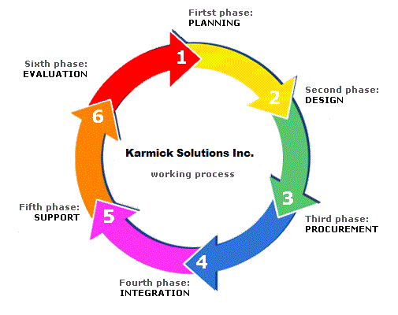
Over many years of industry experience, Karmick Solutions Pvt. Ltd. has developed a methodology that applies to all projects regardless of size, length, and type of service. This continuous process, namely our development life cycle, begins with learning your goals and ends with far exceeding them resulting in the success of your new website & mobile app project.


Step 1: Discover
The first step is to discover and define the exact needs and goals. Karmick Solutions will identify the exact needs so the project is delivered as per your exact needs.

The discovery phase clearly states the problem, and contains all of the information needed to design a solution to the problem. The SRS and detailed FRS will be prepared in this stage of the project.

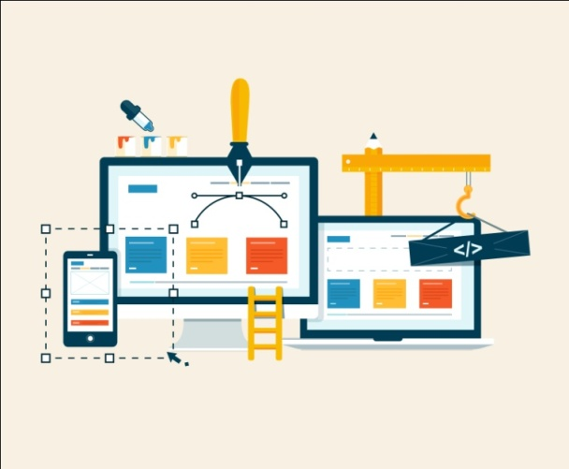
Objective: Goal Identification

Step 2: Design

After we've completed the discovery phase, we come to the design phase. Keeping in mind all your goals and priorities we will begin to design graphic and layout samples.
The navigation structure is one of the main focuses here as well for it must be highly optimized and quick and easy for your visitors to browse.

The aesthetic designers start designing the web pages and mobile app screens for client review.
When the client is satisfied with the proposed "look and feel," we then move forward with development.

Objective: UI Finalization


Step 3: Develop
In the development phase, the web pages as drawn up in the design phase will be created and optimized. The mobile app screens will be sliced and integrated with the web API. Great attention to detail is given and we and utilize standard conventions for good programming style.
Functional beta versions of the site and app are created and every aspect of it is tested thoroughly before posting them to the development server for review of client. Clients/designated member will watch the progress of their development and may participate in testing. The development team will share link/installation file and client can check the progress from time to time. In this phase the following is done

- Work broken up into modules with tentative time-frame attached to each task.
- Development along with Weekly demo
- Feedback Collection on the works done
- The work done in the subsequent week involves the work on feedback collected and new work.
- QA Process at every stage (involves manual testing, regression with test cases and test plan)
- Integration testing once a deliverable is to be delivered.
Objective: Making Site ready for uploading to server

Step 4: Training & Deployment
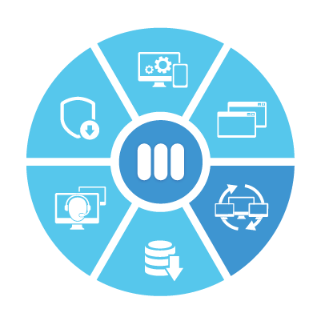
The final stage is training and deployment. Once it is demonstrated that the site and mobile app functions as desired and outlined in our agreed upon proposal, it is uploaded to server. Karmick Solutions team will be having training sessions with authorized representatives prior to go-live so authorized personnel who will take up the website management work are comfortable working with the system.

Objective: Website available to all users using browsers.

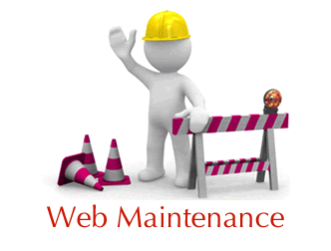
Step 5: Maintain

Maintenance will be provided for 2 months with developer providing support and making fixes for any bugs coming out because of work developed by Karmick..

Objective: Maintenance and Support

Timeframe & Cost:

Phase 1 Timeframe: 3 months

Phase 2 Timeframe: 3 months

Cost:

Phase 1 (with ASP.Net)

Phase 1 Project Fees: USD 8000 (Eight thousand US dollars only)

Phase 2

Web Upgrades
Android & Harmony OS (For Android/Huawei Phones)
iPhone App

Phase 2 total fees: USD 11,000 (Eleven thousand US dollars only)

Payment Milestones (Phase 1):

Payment Milestone | Payment Amount
Project Initiation Advance | USD 2000
Administration & Screen Designs | USD 2000
60% completion of Application | USD 2000
On completion of work and prior to go live | USD 2000
Go Live | 0

Payment Milestones (Phase 2):

Payment Milestone | Payment Amount
Project Initiation Advance | USD 2750
Administration & Screen Designs | USD 2750
60% completion of Application (web/app) | USD 2750
On completion of work and prior to go live | USD 2750
Go Live | 0

Note: On completion of payment for each phase, the source code will be handed over to client and the client will own the full intellectual rights over the code.

Maintenance of Application

Karmick Solutions Pvt Ltd will be providing free support for any bugs identified in the system which comes up due to any development fault/bug that may be present in the system.

After that, maintenance services will commence.

Maintenance service will include maintenance support of up to 20 hours a month. Maintenance service involves support for any issues that may come up in the system due.

Maintenance service will not involve any enhancement works and/or maintenance hours cannot be utilized for new development. Maintenance hours are not carried over to the next month.

The fees for maintenance are US$ 1080 every 3 months. If maintenance works for a month exceeds 20 hours, the additional hours will be billable at US$ 15/hour.

